Do you want to try this out for yourself? Here are the instructions!

Start on the middle line.
- If your parents worked nights and/or weekends to support your family, take one step BACK.
- If you can show affection for your romantic partner in public without fear of ridicule or violence, take one step FORWARD.
- If you have ever been diagnosed as having a physical or mental illness/disability, take one step BACK.
- If you came from a supportive family environment, take one step FORWARD.
- If the primary language spoken in your household growing up was not English, take one step BACK.
- If you were born in the United States, take one step FORWARD.
- If you have ever tried to change your speech or mannerisms to gain credibility, take one step BACK.
- If you felt like you had adequate access to healthy food growing up, take one step FORWARD.
- If you were embarrassed about your clothes or house while growing up, take one step BACK.
- If you are reasonably sure you would be hired for a job based on your ability and qualifications, take one step FORWARD.
- If you or your parents have ever gone through a divorce, take one step BACK.
- If you would never think twice about calling the police when trouble occurs, take one step FORWARD.
- If you have ever been the only person of your race/gender/socio-economic status/ sexual orientation in a classroom or workplace setting, take one step BACK.
- If you can see a doctor whenever you feel the need, take one step FORWARD.
- If you took out loans for your education, take one step BACK.
- If you feel comfortable walking home at night, take one step FORWARD.
- If one of your parents was ever laid off or unemployed not by choice, take one step BACK.
- If you have ever traveled outside the United States, take one step FORWARD.
- If you ever had to skip a meal or were hungry because there was not enough money to buy food, or you had to use food stamps to purchase food, take one step BACK.
- If you feel confident that your parents would be able to financially help/support you if you were going through a financial hardship, take one step FORWARD.
- If one of your parents did not complete high school, take one step BACK.
- If you studied the culture or the history of your ancestors in elementary school, take one step FORWARD.
- If public transportation was a requirement and not a choice, take one step BACK.
- If your parents or guardians attended college, take one step FORWARD.
- If you have visible or invisible disabilities take one step BACK.
- If you ever inherited money or property, take one step FORWARD.
- If you have been the victim or physical violence based on your identity, take one step BACK.
- If your work/school holidays coincide with religious holidays that you celebrate, take one step FORWARD.
- If your family did not have health insurance, take one step BACK.

Follow-up Questions:
- Look at where you are located in regards to where you started: Are you above or below the starting line? How does this position make you feel? Are you surprised about where you are located?
- Where there any statements that you found were more difficult to answer than others?
- If you are standing more towards the front, did you consider yourself as “privileged” before this activity started? How about now? Why or why not?
- If you are standing more towards the back, do you believe you have underprivileged identities?
- If you are in the middle, what do you think about your position after the activity?
- How did the activity make you feel?
- How was this activity helpful?

ADDITIONAL RESOURCES

Tips for being a proactive ally:

1. Understand your privilege. Privilege does not mean that you’re rich, that you’ve had an easy life, that everything’s been handed to you, and you’ve never had to struggle or work hard. All it means is that there are some things in life that you will not experience, or ever have to think about, just because of who you are. For example, there are currently 29 states where you can legally be fired for being gay, and there are 34 states where you can legally be fired for being trans.
2. Listen and do your homework. It sounds like a no brainer, but it’s not possible for you to learn if you aren’t willing to listen, so you got to know to zip up the lip. There are so many people sharing their stories all around the world and connecting with people that they normally would never get a chance to without the power of the Internet. So, do your homework. Start reading, blogs, tweets, news articles, and stories, so that you can get caught up on the issues that are important to the communities that you want to support.
3. Speak up, but not over. An ally’s job is to support. You want to make sure that you use your privilege and your voice to educate others, but make sure to do it in such a way that does not speak over the community members that you’re trying to support or take credit for things that they are already saying.
4. Realize that you’re going to make mistakes, and apologize when you do. Nobody’s perfect. Unlearning problematic things takes time and work, so you are bound to mess up. Just remember that it’s not about your intent, it’s about your impact, so when you get called out, make sure to listen, apologize, commit to changing your behavior, and move forward.
5. Last, but certainly not least, remember that ally is a verb. Saying you’re an ally is not enough. You got to do the work, one through four, one through four.
http://everydayfeminism.com/2014/12/tips-for-proactive-ally/
In this completely revised, “Remix” version of his highly-acclaimed memoir, White Like Me, Tim Wise explores how racial identity and whiteness influence the lives of white Americans, by examining how they have impacted his own life. Wise examines what it means to be white in a nation created for the benefit of those who are “white like him,” and how privilege seeps into every institutional arrangement, from education to employment to the justice system. Importantly, he also discusses the ways that white privilege can ultimately harm its recipients in the long run and make progressive social change less likely. Through personal storytelling and convincing analysis, Wise makes the case that racial inequity and white privilege are real and persistent threats to personal and collective well-being, but that resistance to white supremacy and racism is possible.
http://www.timwise.org/books-and-dvds/white-like-me/
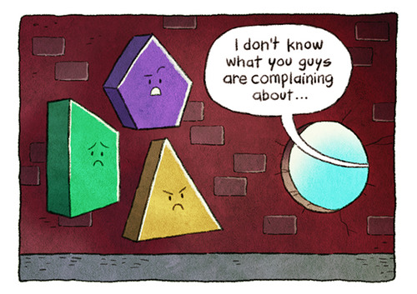
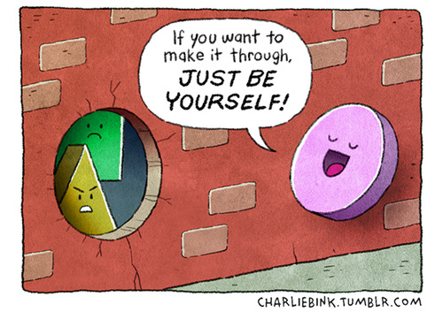
For more information on privilege, please visit:
http://everydayfeminism.com/?s=privilege

